Asana Changes
What’s new:
- Custom fields ‘Hours Expected’ and ‘Time Taken’ added to all projects
  - This has been done to: allow all members of the team to see each other’s bandwidth and stop over tasking any member of the team ahead of time; the real time taken for completed projects to then plan time, price and profitability of future projects.
- Default Project Template (all future website projects) changed from board to list view
  - This has been done to facilitate the removal of all subtasks, as we now require ‘Hours Expected’ and ‘Time Taken’ custom field values to be entered (possible at task level only).
- On Time Status dropdown
  - This has been added to give both user and team leader one click notification of impending issues/delays with a task, for an easier overview of tasks that need to be rescheduled. Further info below.
- Task Progress dropdown
  - This has been added to give the team leader visibility of whether a task is in progress or not before rescheduling without having to call/message and await confirmation. This box will help determine the order in which tasks are rescheduled (when needed) to make sure a task that is already underway spans as few days as possible.
Housekeeping:
- ‘Hours Expected’ and ‘Time Taken’
  - On creation/allocation of a new task, as well as adding the hours expected to the task name (i.e. (0.10) Initial Mock-up Submission) the same value will needed to be added to the field found here:

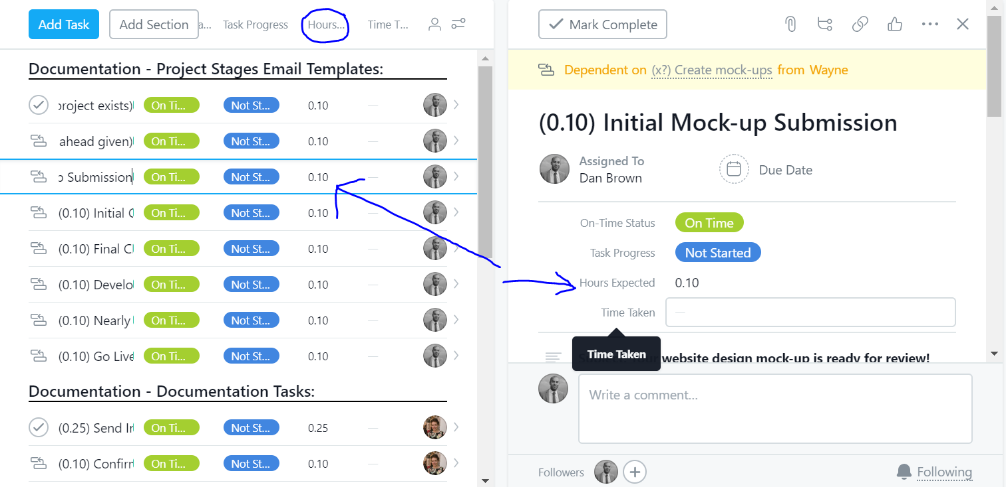

  - On completion, the time taken without interruptions (no stopwatch needed!) is to be added to the next box along/below ‘Time Taken’
- On Time Status dropdown
  - Consists of three options:

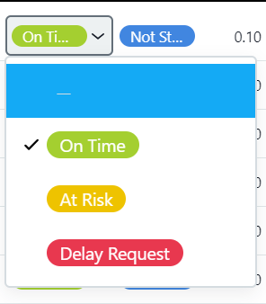

On Time (default)
At Risk: selected ahead of time if you think a task won’t be completed on the scheduled day for any reason
Delay Request: selected immediately it is clear that a task will need to be rescheduled

- Task Progress dropdown
  - Consists of five options:
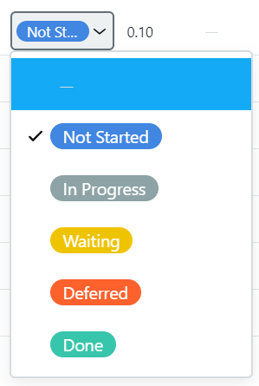

Not Started (default)
In Progress: task started but not completed
Waiting: task awaiting input from another team member/client
Deferred: task delayed until a later date
Done: task completed!

Notes:
On Time Status & Task Progress dropdowns only currently applied to Website Projects
No custom fields can be seen from the ‘My Tasks’ screen, but can be seen once the individual task is clicked on:

